**Task 01**

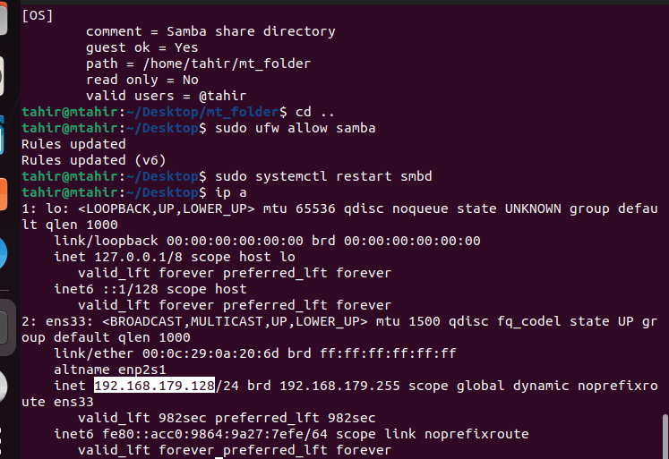

**Task02**

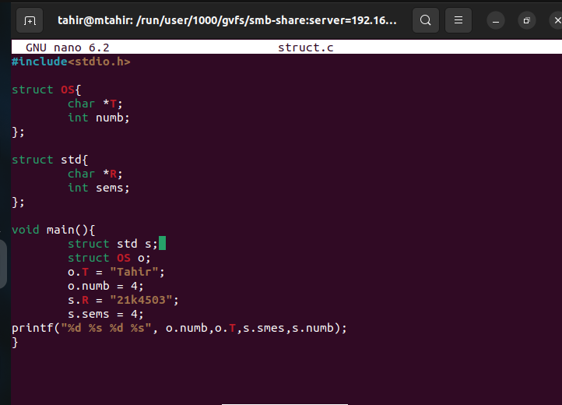

**Task03**

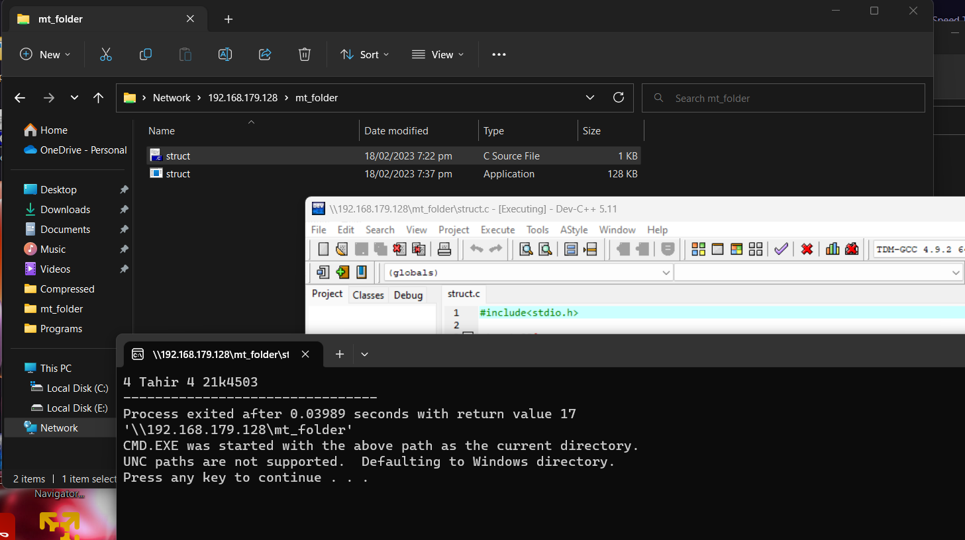

**Task04**

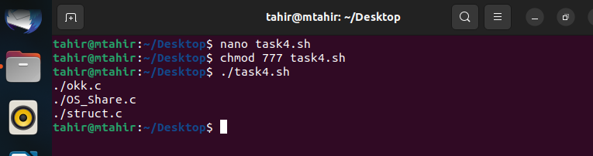

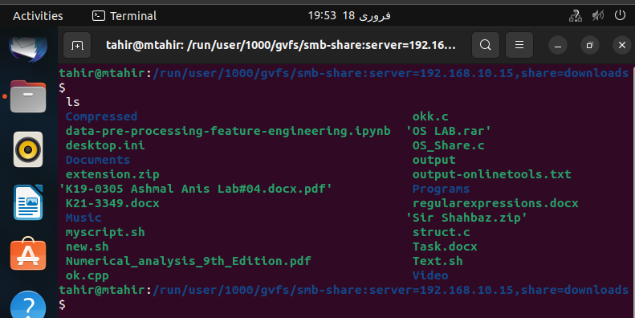

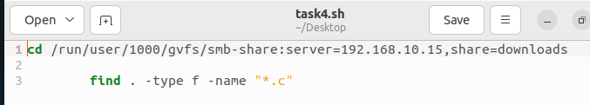

**Task05**

